Search MIT App Inventor 2 in google

Click “MIT App Inventor 2”

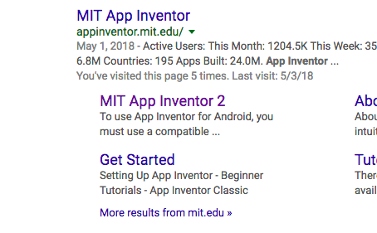

Set up account if needed

Download the .aia file from the drive

Select “Projects” dropdown in app inventor

Select “Import project (.aia) from my computer …”

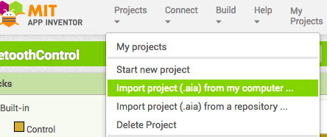

Choose the .aia file and then you will have the app and can make any changes you’d like to.